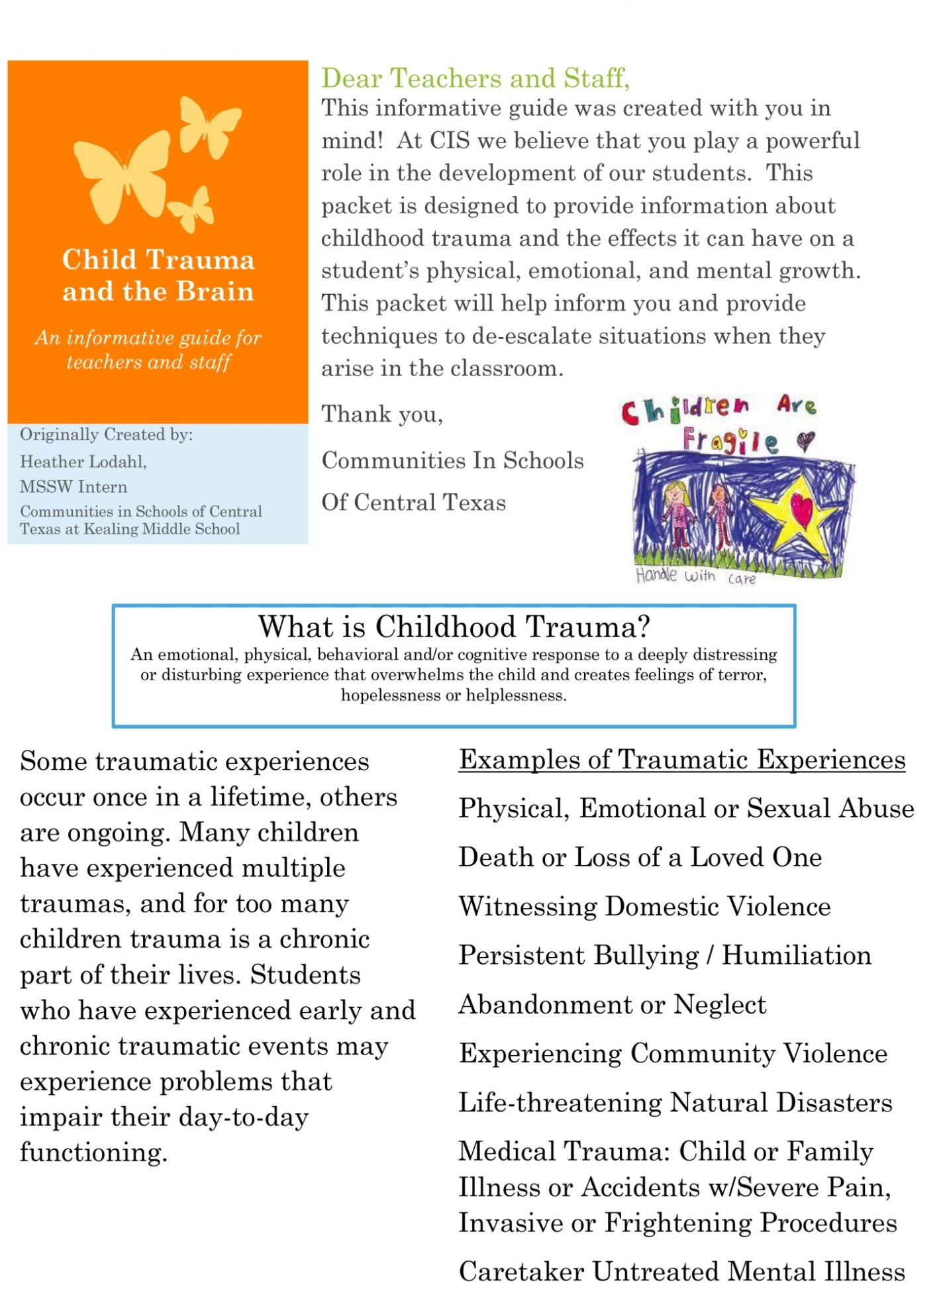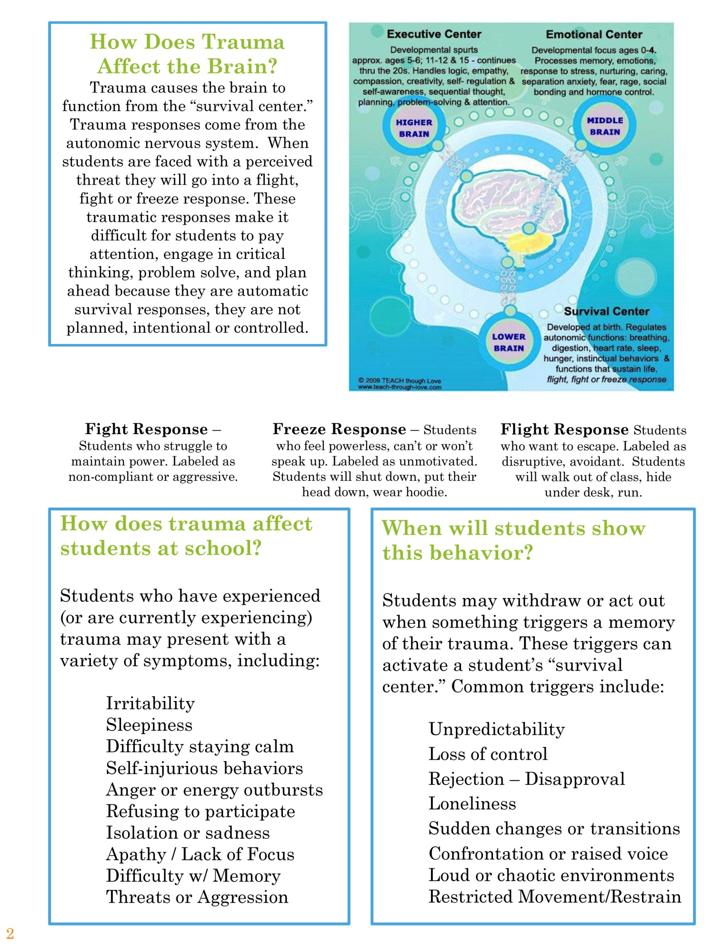
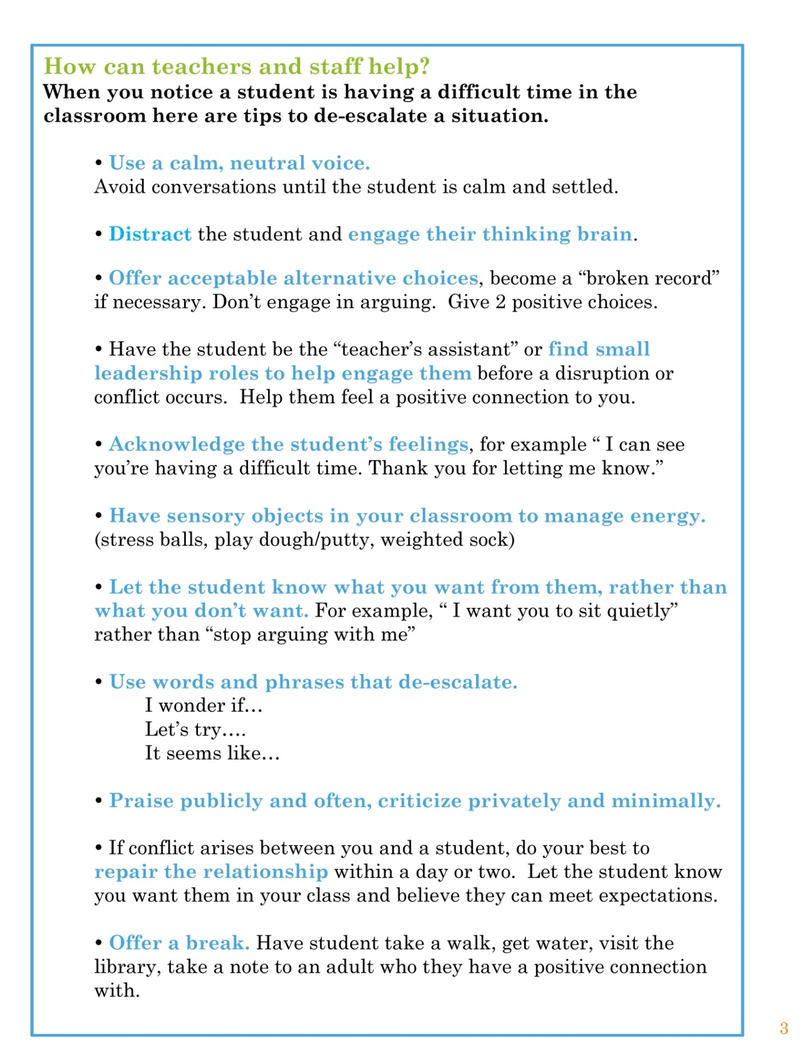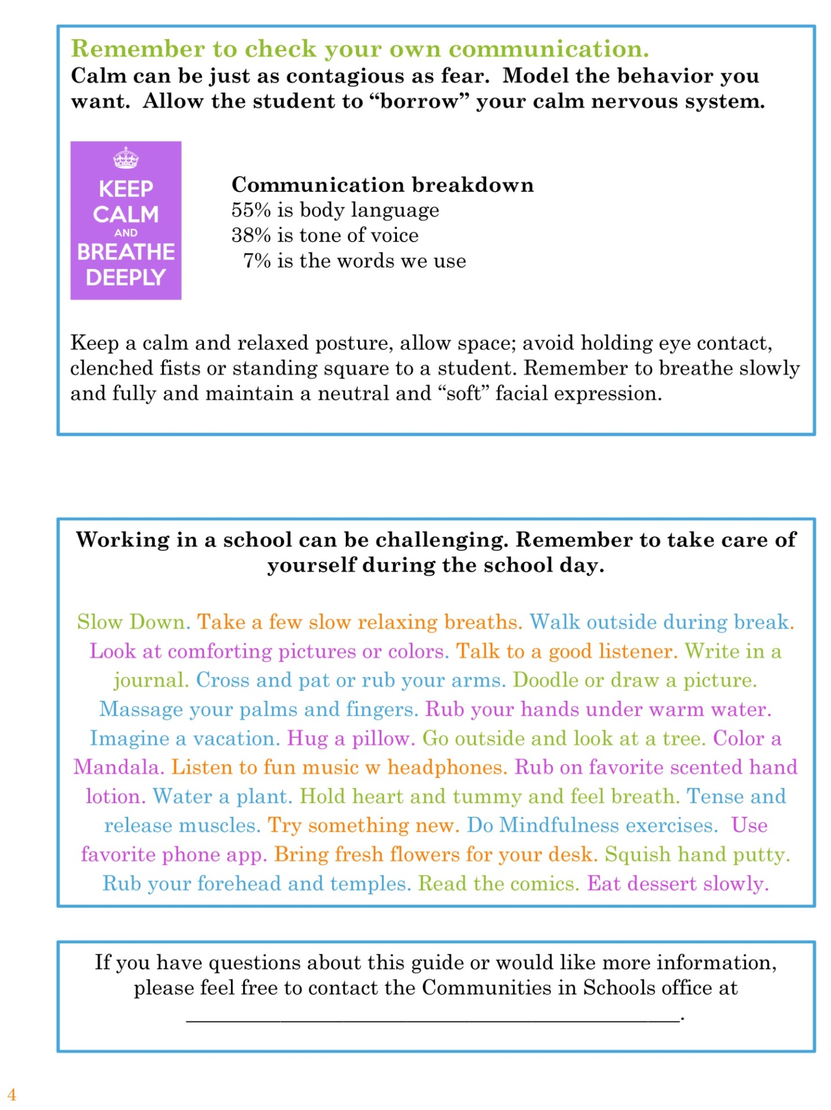
Working in a school can be challenging. Remember to take care of yourself during the school day.
Slow Down. Take a few slow relaxing breaths. Walk outside during break. Look at comforting pictures or colors. Talk to a good listener. Write in a journal. Cross and pat or rub your arms. Doodle or draw a picture. Massage your palms and fingers. Rub your hands under warm water. Imagine a vacation. Hug a pillow. Go outside and look at a tree. Color a Mandala. Listen to fun music w headphones. Rub on favorite scented hand lotion. Water a plant. Hold heart and tummy and feel breath. Tense and release muscles. Try something new. Do Mindfulness exercises. Use favorite phone app. Bring fresh flowers for your desk. Squish hand putty. Rub your forehead and temples. Read the comics. Eat dessert slowly.

Classroom Strategies
1. Keep a Calm and Predictable Environment: Continually take the “temperature” of your classroom. If a classroom is loud and chaotic, and you need to raise your voice in order to be heard and regain the focus of the class, then students with a trauma history will likely stay in a very high, uncomfortable state of arousal, agitation, and can easily become overwhelmed and reactive.
- Keep your own voice calm. Use bells or chimes to get class attention. You may allow students to also use the chime when you need to get the attention of the class, and then have a regular phrase or movement that helps to bring everyone’s focus back to you.
- Review the morning or afternoon agenda / or class period’s agenda at the beginning of class.
- Post schedules (with visual cues) for the day.
- Have opening and closing rituals (ex. circle time) which provide a sense of safety and predictability for students.
2. Prepare Students for Transitions:
- Give an orientation to the transitions at the beginning of the day. (ex. We will be going outside for recess at 11:15, and then going to the cafeteria for lunch.)
- Provide a reminder 5 minutes before a transition. “In a few minutes we’ll put our reading books away and get ready for the lunch bell.”
- Be sure to let students know a few minutes ahead of time if an adult visitor plans to come into the class. Introduce the visitor and their purpose to the class.
3. Back Up Strategies – It is important to have a plan for students who you know have a pattern of becoming overwhelmed. Often times, this involves collaborating with a counselor, administrator, or other support staff. Teachers need strong back-up support for handling challenging behavior.
- Know who you will call for back up if you need assistance with a student. Ideally, if the student is connected to you, the “back-up person” may come in and take over class so that you can step out and help the student to calm and co-regulate with you. This strengthens your connection to the student, and doesn’t make them feel unwanted in the classroom.
- Talk w/ the teacher who has the best relationship with the student (maybe a former teacher or specials teacher). Ask them what worked best for them in connecting and calming this particular student in the past. Consult them in times of need.
- When you have a substitute, prepare the student, and have a backup place where they can go if they need to leave and have a familiar place to work. (ex. Favorite teacher’s classroom)
- Practice calming skills frequently and have the student choose which ones work best for them. Have a list or pictures of these skills at the student’s desk or in their binder. For younger students, you can take pictures of the student using the skills and keep those at their desk.
- Brainstorm back-up ideas with other support staff (SEL, CIS, nurse, Occupational Therapist – OTs are very knowledgeable about how to settle over-reactive nervous systems - teacher’s aide; someone who already has a positive and nurturing connection to the student)
- Keep water bottles, snacks, and blankets on hand to meet basic needs.
4. Make a Quiet Place: Normalize the use of a Calming Corner / Chill Corner, as a place for students to chill or relax when they start to have “too much energy” and need to get back in their “green zone”.
- Bean bag chair and low shelf for some privacy.
- An extra table in the back where the student can go if they need to be away from others.
- Calming items available such as Ear Plugs, Mandalas w/ Coloring Tools, Picture Books of Animals, Putty or Stress Balls. See more examples in the Handout (pg. 14-15).
5. Take a Sensory Break: Allow the student to request (or you offer for them) to step out of the classroom when they need a break. Even though this may distract them from their school work, they will not be able to concentrate anyway if they are hyper-aroused. Taking a break is much better than letting them get to the point of overwhelm and reactivity.
- Visit the Water Fountain, hydration is VERY important to help self-regulate.
- Visit the Library and find a book that they enjoy.
- Take a note to the office and give it to the school secretary (or that super friendly person in the front office or counselors’ secretary, who loves everyone and makes them feel extra special).
- Go to the bathroom – “Bodily Elimination” is an automatic stress response for some students.
- Have a place outside of class where they can take their work, but not in the hall exposed to passersby – as this often produces more discomfort and agitation because the student doesn’t know what or who they might encounter in the hall.
- Walk around the track.
- Have a table in the back where they can move to, crawl around or under, etc. when needed.
6. Show Kindness to Each Other: Giving everyone opportunities to feel connected and helpful to their classmates. This is especially important for students who have a difficult time connecting and feeling accepted by their peers – to be helped AND be the helper. Create a system for students to be a “buddy” or positive leader. You may also have a regular “nurturing group” time to check in with everyone and offer support, or do a “bonding” activity. This takes training and practice to keep it positive, nurturing and supportive, and avoid confrontation. Ask your school counselor for ideas.
- Assign a classmate to buddy with a student for difficult assignments during class (ex. Math Buddy”), review work together, remind each other to turn in homework, etc.
- Help someone feel better – student walks with them to see the nurse or the counselor, or shares something that makes them feel good.
- Place a more isolated or anxious student next to a friendly, non-judgmental student and encourage partner work.
- Ask student to show a new student around and make introductions to office staff, orient the new student to different parts of the school, etc.
- Have student introduce new students to the calming corner; show them how to use the tools.
- Class Leaders/Teacher Helpers – water plants, lead class in morning ritual, pass out papers or supplies, collect up work, ring “focus” chime for you, care for class pet, or lead the line.
7. Identify Triggers in Class and Work to Reduce Those Triggers – Be a “detective” and notice when a student seems to be triggered / stressed: time of day, activity/subject content that they are doing or getting ready to do, level of activity and energy / noise in the classroom, where they are sitting, if they’ve eaten food, who they are sitting next to or around, if they are sleepy.
- Move the student to their most comfortable part of the classroom. (let them choose)
- Keep noise level down and offer student ear plugs if they have to endure a louder activity.
- Ask the student how they wish to be addressed / greeted when they walk into class. They may want to be acknowledged, or not have any verbal communication. Smile often at them!
- Have a verbal or visual cue to check in and see if they need academic or emotional support.
- If they are comfortable with touch, briefly put your hand on their shoulder or their back to reassure that you are there and a safe connection for them. If touch isn’t a good choice, then put a smiley face note, sticker or other symbol of greeting / connection on their desk.
- Allow them to send you a note to let you know they need a break.
- Reduce clutter and avoid too much “decoration” on the walls. This can be overstimulating.
- Keep them separated from classmates that may provoke or make the student uncomfortable.
8. Take stretch breaks and practice Mindfulness every day. – Allowing for movement when students have too much energy is critical for self-regulation. Imagine your discomfort when you feel the need to move or take a break. It is unthinkable for adults to not be able to go to the bathroom or get water or stretch or walk when we need to. But students often times have their movements highly regulated.
- Stop and stretch with the whole class. Do bi-lateral activities (Brain Gym, Yoga Pretzels).
- Have students move around to different centers or areas to complete an assignment.
- Get a book or card set of Mindfulness activities and pause several times during the day to slow down, notice how everyone is presently feeling, and connect to their breath. It will re-invigorate the student’s attention and energy, and help them be more receptive to learning.
- Put up Mindfulness Activity Posters, which students can request the class to do as needed.
Daily Mindfulness is very beneficial for teachers to build self-reflection skills and an awareness of their own internal state and level of stress. This allows teachers to model and teach self-regulation skills.
Possible Teacher Questions & Concerns
Is it helpful for me to know about the student’s trauma history? Trauma history should only be shared on a NEED TO KNOW basis for the student’s safety. We do not want to ask them about their trauma history, as this can re-traumatize the student. Early trauma experiences are pre-verbal. It isn’t necessary for us to know their trauma story. It is only necessary for us to recognize that they need extra support for emotional regulation, and use our skills to help them feel calm and safe.
What is so important about tone of voice? Two areas that the “survival brain” responds to the quickest are nurturing touch and a soft, non-threatening tone of voice. Since touch is not recommended if we don’t have a close relationship with a student, using a slow and soft tone of voice is the most reliable way to establish safety. It will also help to slow us down and calm our own nervous system.
Why not limit their movement so they can’t run, hurt themselves or someone else? Restricting movement will always produce an automatic threat response. That is hard wired into us as humans. Having space to move around and the choice to do something with the surge of survival energy that is released will automatically help the student to feel safer. Provide safe choices (let’s take a walk).
Why offer water and/or snacks? When we start to feel thirsty, we lose 10% of our cognitive functioning. A simple drink of water and food for healthy brain power can go a long way in settling a student’s dysregulated system. Always focus on basic needs first: thirst, hunger, and physical comfort.
Why do they always want to go to the bathroom? Bodily elimination is an automatic survival response to (perceived) threat. It is hardwired into our system. It also provides a break to allow time to calm.
Why talk about dissociation? A student who has a pattern of shutting down / freezing / dissociating is often misunderstood, and can easily be re-traumatized. Dissociation is the hardest pattern to change because the student’s survival brain does not see any hope of escaping or resisting the trauma, and so it shuts down. This type of trauma response is deeply rooted and requires thoughtful intervention. This knowledge is especially important for counselors, school nurses, teacher’s aides, and administrators.
Why do we offer sensory objects? Children with a history of trauma are going to have strong reactions to a variety of sensory experiences. They will either avoid certain sensory experiences, or seek out other sensory experiences in order to manage the survival energy that is released into their bodies. The sensory object will help to organize their energy and settle their nervous system. Every child is different and will have their own “sensory menu” of helpful things and things they need to avoid.
What if the student misuses sensory objects? Brainstorm with the counselor / trauma coach which helpful objects will be easiest to incorporate into the classroom. Practice using the sensory object in class with the student when they are calm. Then they will be more likely to use their sensory tools successfully when they are upset and need them.
What if other students say it isn’t fair for the student to have special objects? Either make the objects available to anyone who needs them – normalizing them – or say that everyone needs different things at different times, and right now this is something helpful for your student.
What if I just ignore their behavior? I really don’t want to reward or encourage more of the behavior. Trauma behaviors are fear reactions, and they are automatic survival responses – in other words the student is not deliberately and intentionally acting this way. They are a clear sign that the student is overwhelmed and does not feel safe in that moment. If we ignore, we allow the child’s fear to continue to rule their behavior. We have to act intentionally in order to help the student build a sense of safety and regain a sense of control. This also allows the child to see us, the adult, as capable of helping them feel better. This will start to build a stronger, safer connection between the child and us. And it allows us to have much more influence when they do become upset.
When I give choices, should I give the “right choice” and then the “consequence” of a bad choice? No. It is important to give two positive and acceptable choices, so the student has a feeling of power and control, but can choose which one feels best for them in that moment. Get creative – there is always more than one way to approach a problem or settle a difficult situation.
I think it is important to establish my authority and be consistent with everyone. Authority is built on respect, and respect from a child is contingent on feeling safe and good with the adult. Authoritarian methods are often fear-based, and will only add to the child’s lifetime of living and reacting to a fearful environment. They need practice in feeling safe and cared for, in order to build the skills to soothe themselves, stay present and open to learning, and make good choices. Not all students have had these fearful life experiences, but all students will thrive and respond well to feeling safe and cared for.
Isn’t it better to just send the student out of class rather than take the time to try and “co-regulate” with them during class time? Many of these students feel very disconnected and are used to feeling abandoned and separated from other adults and peers. Our biggest goal is to help the student feel connected to their teacher, and know that the teacher can help them to stay safe. Once we establish that connection, they will be MUCH more responsive to our efforts to help them learn new skills and correct their ineffective behaviors. The short time that it takes to notice when a student is getting dysregulated, step in and help them to settle, will not only avoid a lot of drama and stress, but it also helps the entire class know that the teacher can keep them all safe and feeling calm in the classroom.
I can’t step out of class to help one student when I have 25 other students needing my attention. This is a dilemma for classroom teachers, but one that many teachers have successfully planned for. Perhaps keep the door open, have a short activity in your “back pocket” for such times. (“Take out your books and do some quiet reading.”, or “Take a few minutes to write down the most important thing we discussed today.”), and stand or sit just outside the open door so that you can focus a minute or two on the student while still keeping an eye on the class. Or perhaps have a next door teacher’s aide or administrator that can step in and watch the class while you spend a minute or two with the student. Stepping out into the hallway isn’t unheard of, it seems to happen on a pretty routine basis when taking a private phone call, etc., but doing it in order to calm a student takes a readiness to assume the role of co-regulator when a student needs you to help them feel safe again. This helps to avoid both the student and teacher becoming upset, having to call for crisis help, upsetting all of the students in the classroom, having to escort a student to the office, clear out a classroom, or set the student up for future teasing and belittling by their peers because of their fear reactions.
School Interventions for Working with Traumatized Students

Keep in mind that as a teacher you may not see a specific antecedent. When students have been traumatized, a single facial expression, words, smells, etc. can set off the student’s internal alarm. Once this happens, the “thinking/rational” part of the brain shuts off and the “instinctual” part (seeking to protect itself against a perceived threat) kicks in. At this point, asking a student to “Stop and think” will not work. The nervous system of a student who has been traumatized has become compromised (Trauma Through A Child’s Eyes, Levine & Kline, 2007).

In his book Beyond Time Out, John Stewart Ph.D., states that for healthy emotional development, students must have: an atmosphere that creates a fundamental and pervasive sense of safety, a [classroom] climate where all students can enjoy a sense of belonging and circumstances that provide frequent and expanding experiences of competency.

Safety
- Establish a safe spot in the classroom, direct teach and remind student how to use this; reinforce and praise student for using it; ensure a calm and reassuring presence
- Direct teach and practice calming/relaxation strategies.
- Consistency of expectations, procedures and routines creates safety (remind student frequently of these); make student aware as much as possible of changes in schedule, routine, etc.
- Respect student’s physical boundaries. Many students who have been traumatized may react strongly to touch, feeling cornered or restricting their movement.
- Have built in breaks for movement (movement is regulating). Many students who have been traumatized get overwhelmed easily and movement allows them to get rid of excessive energy and regulate.
- Give student breaks if you notice overwhelm building or agitation

A sense of belonging
- Have specific times of day to check in with student;
- Include student in small group with peers
- Provide opportunities for student to be involved in
Class / school (class job, run errands, etc.)
- Verbal / non-verbal praise often
- Smile often at them and help them feel connected to you

A sense of competency
- Provide many opportunities for student to be successful in non-academic activities
- Label student’s feelings often (“You worked hard on your math test. You must feel proud.”) Traumatized students often have difficulty labeling/recognizing feelings
- Allow student opportunity to express concerns/frustrations and help student problem-solve
- Praise efforts to communicate needs

STEPS for Building Safety
These strategies were demonstrated in the video to help students start to return to their Thinking Brain (Green Zone) – and given enough time, then they CAN talk and problem solve with you. These skills will help prevent us from unintentionally re-traumatizing our students.
Check the strategies (√) that work for you……
___ Invite them to slow down and take a breath.
___ Give them choices like, “Where would you like to sit?”
___ Use a soft tone of voice and soft facial expression.
___ Ask them if they want to move around or get a drink of water.
___ Take a breath with them and model ways to settle.
___ Invite them to rub their hands together, or cross their arms over their chest and either pat, rub or squeeze their upper arms, and do this with them.

___ Offer ear plugs or heavy pillows to help calm their system.
___ Take a step back to give them more space.
___ Make an empathy statement.
___ Get down on their level, so that you appear less intimidating.
___ Encourage them to take all of the time that they need.
___ Let them know that it’s OK to shake or tremble, and encourage them to let that energy just move on out of their system.
___ Reassure them that you are there to help, and ask them how you can help.
___ Help them orient to something else – something that is relaxing or cheerful, like a poster or mural with nice colors, or an interesting object.
___ First, slow down, take a breath, check your internal state, put on your own oxygen mask, and get yourself grounded, feel your feet on the floor.

General Guidelines for De-Escalation

(Trauma Through A Child’s Eyes, Levine & Kline, 2007 , pg.341) – Helping Students Get into the Green Zone for Learning

1. Be aware of your own activation or triggers in this situation. Take a step back and a deep breath to let your energy settle. Feel the energy settling into your feet, and the support of the ground. (It is only natural that if a student has become aggressive, shut-down, etc., our adrenaline will begin to surge).
2. Remind yourself that you know what to do because you understand this list.
3. Adopt a soothing tone of voice: raising your voice provokes more adrenaline.
4. Check your posture and facial expression. Avoid threatening behaviors or gestures.
5. Take another step back and state the behavior you observed without shaming or exaggeration. “You tore your worksheet and got under the desk.”
6. Show that you understand your student by reflecting her overwhelming feelings. “I can see that was frustrating and really uncomfortable for you.”
7. Ask “Can you tell me what happened?” rather than “Why did you do that?”
8. Avoid threatening or punishment.
9. Make a statement that shows the student that she is not alone: this will assist her in calming down. “I’m right here and I’m going to help you feel better.”
10. Make a statement that shows that the relationship between you can be repaired. “Take all the time you need and we’ll figure it out.”
11. Make a statement that gives a choice to save face. “When you’re ready, you can let me know how you want to handle the worksheet.”
12. Make a statement that shows the correct behavior, and/or what can repair the infraction. “We can figure out how you can let me know when you get frustrated and use that next time.”

All of the above interventions can be used on a student’s intervention plan. The most important thing that you can do is to “lend the student your regulated and calm nervous system.” That will allow them to calm and settle.

Trauma Informed School Accommodations / 504 / BIP / Recommendations

__________________(student) I recommend the following accommodations in the classroom and school setting, to support their being successful in the learning environment.

__ Respect student’s boundaries, allow ____ feet of personal space.

__ Allow ____ minutes to calm before discussing behavior & consequences. (calming corner)

__ Communicate with a calm voice & facial expression. Don’t use raised voice or shaming tone.

__ Plan with student the most comfortable way for them to enter the classroom and how to be greeted or acknowledged by the teacher to reinforce comfort.

__ Verbally reassure student’s safety and allow plenty of time and personal space for student to regain a sense of calm when they are distressed or agitated.

__ Provide a quiet, neutral (non-punitive) space for calming & settling, completing daily school work when requested, testing, and other high stress school activities.

__ Teach and reinforce strategies for calming, such as grounding, breathing, guided activities.

__ Allow student to chew gum, use stress ball, weighted pillow, or other soothing manipulatives during class. Insure student’s feet touch the ground or use a foot stool for grounding.

__ Provide an OT Evaluation & Intervention Plan to identify and reduce sensitivity to sensory overstimulation / integration difficulties and triggers in the classroom.

__ Allow frequent water and stretch breaks and daily recess or walks as needed, or by request.

__ Provide a calm, nurturing, predictable and structured classroom environment.

__ Provide a list of relaxation strategies (w/ visual graphics) at student’s desk.

__ Prepare and allow extra time for transitions. For secondary students, consider changing classes a few minutes early so that they do not have to negotiate crowded, loud hallways.

__ Assign a student partner / study buddy to work with in class or walk between classes.

__ Enhance student privacy __ wearing hood to block peripherals, __ turn lights down and sit in back of class or less lit area, __ exempt from group work w/ individual options provided.

__________________________________ _______________________
School Faculty (teacher, counselor, admin) or Mental Health Provider Date

